
HWA CHONG INSTITUTION
C2 Preliminary Examination
Higher 2

CANDIDATE NAME |  |  | CT GROUP | 09S

CHEMISTRY  Paper 1 Multiple Choice  Additional Materials: Multiple Choice Answer Sheet  Data Booklet. | 9647/01  24 September 2010  1 hour

READ THESE INSTRUCTIONS FIRST

Write in soft pencil.
Complete the information on the optical mark sheet (OMS) as shown below.
Write your name
Write and shade your NRIC
or FIN number
Write your CT group
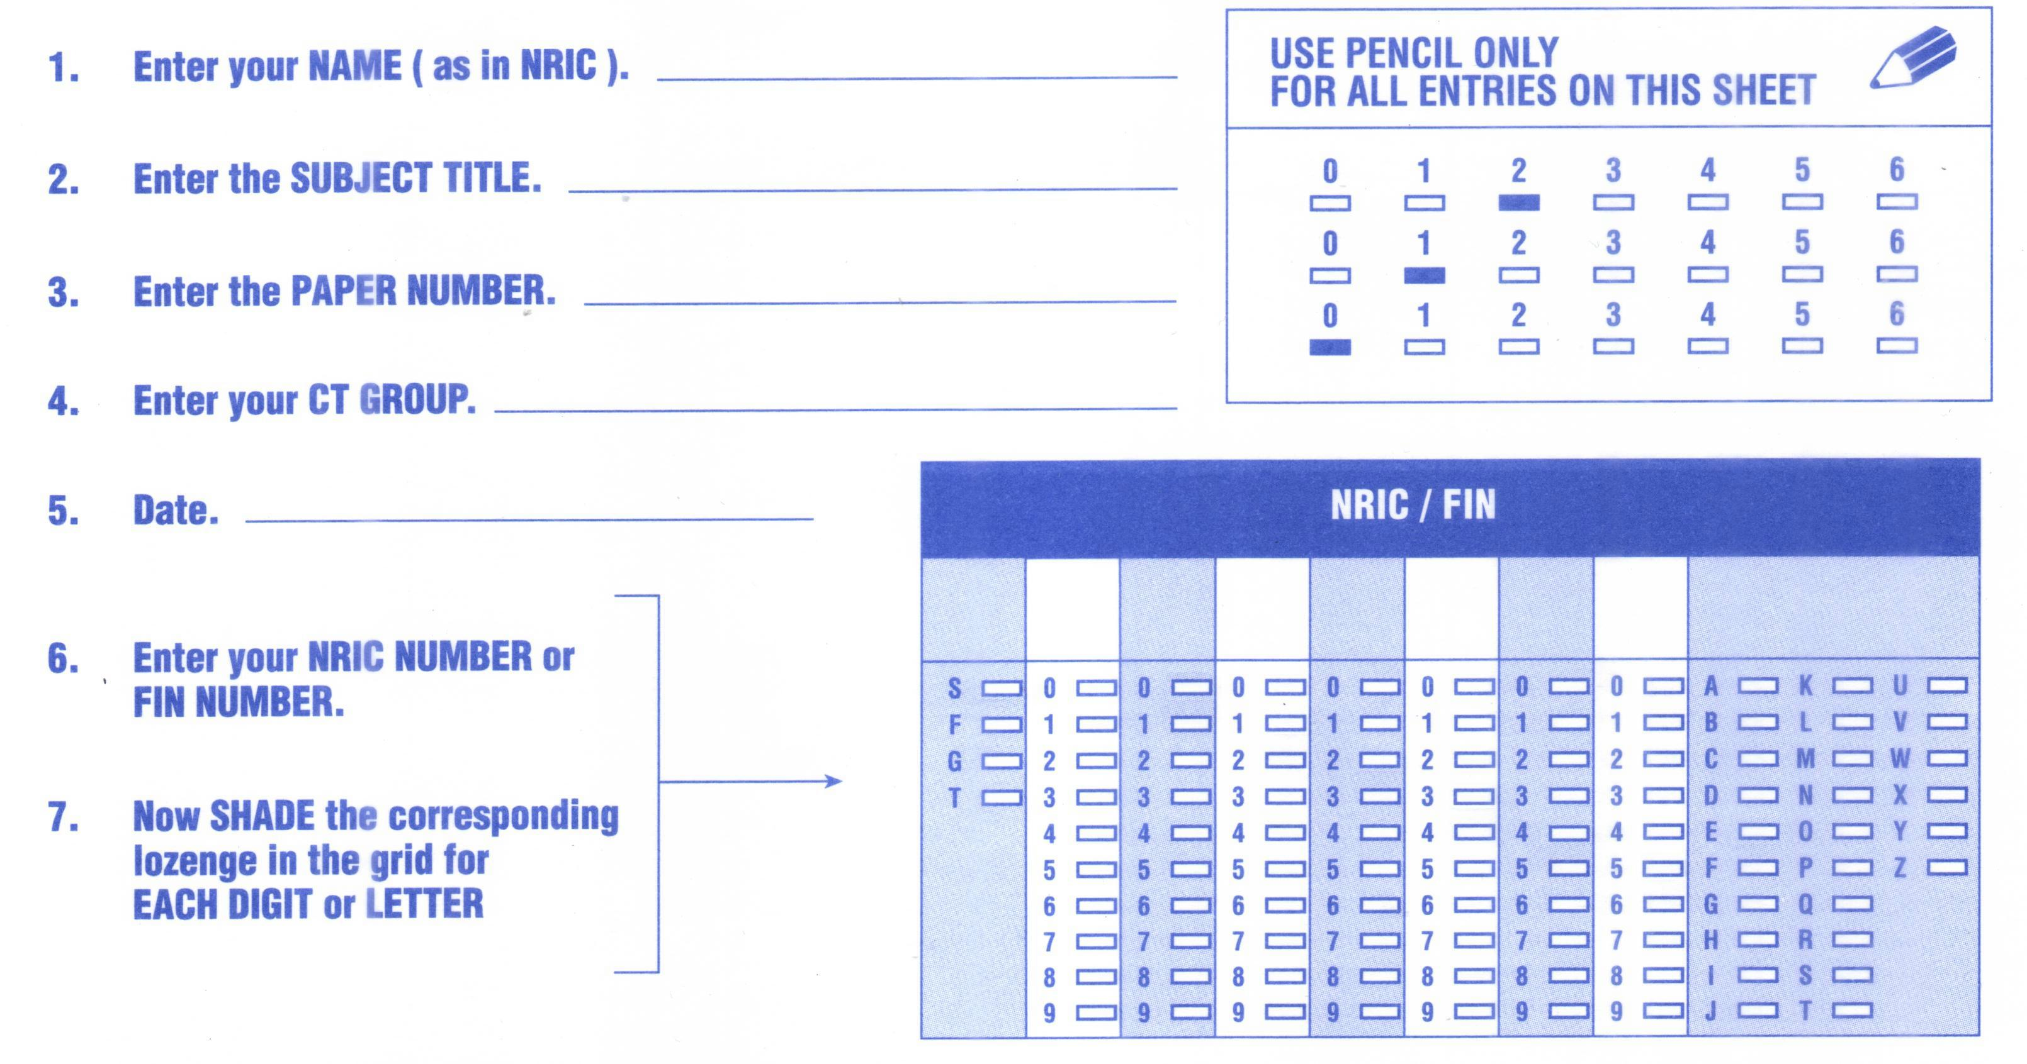
There are forty questions on this paper. Answer all questions. For each question, there are four possible answers A, B, C and D.
Choose the one you consider correct and record your choice in soft pencil on the OMS.

Each correct answer will score one mark. A mark will not be deducted for a wrong answer.
Any rough working should be done in this booklet.

Section A

For each question there are four possible answers, A, B, C and D. Choose the one you consider to be correct.

1 | Which of the following statements is correct?
A | 24 dm³ of hydrogen gas at 25 °C and 1 atm contains 6.0 × 10²³ hydrogen atoms.
B | 500 cm³ of 1 mol dm⁻³ aqueous copper(II) nitrate, Cu(NO₃)₂, contains 3.0 × 10²³ nitrate ions.
C | 256 g of sulfur contains 6.0 × 10²³ S₈ molecules.
D | 1 mole of sodium hydrogensulfate, NaHSO₄, dissolves in water to form 1.8 × 10²⁴ ions.

2 | The foul smell that skunks spray is due to a number of thiols, one of which is methanethiol, CH₃SH, which burns as follows.  CH₃SH + 3O₂ → CO₂ + SO₂ + 2H₂O  A sample of 10 cm³ of methanethiol was exploded with 60 cm³ of oxygen.  What would be the final volume of the resultant mixture of gases when cooled to room temperature?
  A | 20 cm³ | B | 30 cm³ | C | 50 cm³ | D | 70 cm³

3 | An element X forms an ion X^{n+}.  Which of the following statements about X and X^{n+} is correct?
A | The radius of X^{n+} is greater than that of X.
B | The number of protons in X^{n+} is greater than that of X.
C | Less energy is released when an electron is added to X^{n+} than to X.
D | More energy is required to remove the outermost electrons from X^{n+} than from X.

4 | 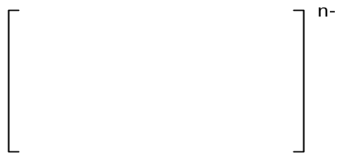An ion IF₄^{n−} has a square planar structure as shown below:  n−  F  F  I  F  F  What is the value of n?
  A | 1 | B | 2 | C | 3 | D | 4
5 | Ice is the crystalline form of water. The diagram below shows part of the structure of ice.  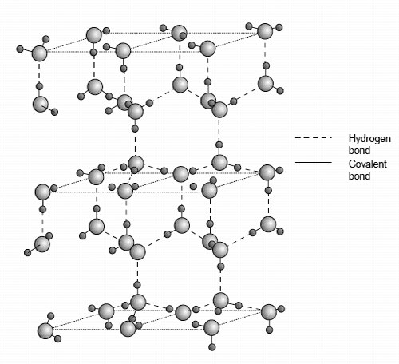  - - - - Hydrogen bond  Covalent bond  Which of the following statements is not true about ice?
A | Ice has a lower density than water at 0 ºC due to its open structure.
B | The bond angle about oxygen in ice is 109.5º.
C | Ice does not conduct electricity.
D | Ice has a giant covalent structure.

6 | Typically, when a person coughs, he first inhales about 2.0 dm³ of air at 1.0 atm and 25 ºC. In the lungs, the air is warmed to 37 ºC and compressed to a volume of about 1.7 dm³ by the action of the diaphragm and chest muscles. The sudden opening of the vocal cord then releases this air explosively.  Just prior to this release, what is the approximate pressure (in atm) of the gas inside the lungs?
  A | 0.88 | B | 1.2 | C | 1.7 | D | 3.7 × 10⁻⁵

7 | Instant ‘hot packs’ are often used by athletes to conveniently treat injuries. One type of ‘hot packs’ is composed of powdered magnesium sulfate and water separated by a thin plastic membrane. When the pack is squeezed, the membrane breaks and the magnesium sulfate dissolves in water.  MgSO₄(s) + nH₂O(l) → MgSO₄(aq)  Which line in the table gives the signs of ΔH, ΔS and ΔG for the overall process?
   | ΔH | ΔS | ΔG
  A | − | + | −
  B | − | − | +
  C | + | + | +
  D | + | − | −
8 | Which one of the following is a correct statement about the effect of a catalyst?
A | It increases the equilibrium constant for the forward reaction.
B | It increases the rate constant for the forward reaction but not that of the back reaction.
C | It increases the speed of the reactant particles and therefore the rate of molecular collision.
D | It provides an alternative route for a reaction.

9 | Two bulbs R and S, connected by a mercury manometer, are held in a thermostat as shown. The volume of R is twice that of S. R contains a gas at the same temperature as nitrogen in S.  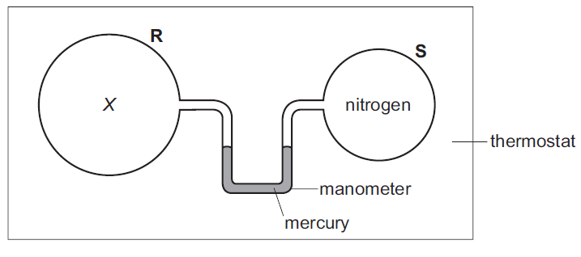  N₂  When the temperature is increased, which of the following gases in bulb R would cause the mercury level in the right-hand limb of the manometer to rise?
A | an equilibrium mixture N₂F₄(g) 2NF₂(g); ΔH > 0
B | an equilibrium mixture H₂(g) + I₂(g) 2HI(g); ΔH > 0
C | an equilibrium mixture CH₃NC(g) CH₃CN(g); ΔH < 0
D | an equilibrium mixture 4NH₃(g) + 5O₂(g) 4NO(g) + 6H₂O(g); ΔH < 0

10 | The table below shows the values of the ionic product of water, K_{w}, at two different temperatures.  Which of the following statements is correct for pure water?
  Temperature / ºC | K_{w} / mol² dm⁻⁶
  25  62 | 1.00 × 10⁻¹⁴  1.00 × 10⁻¹³
A | The ionic dissociation of water is an exothermic process.
B | At 62 ºC, pH = 14 − pOH.
C | At 62 ºC, pH < pOH.
D | At 62 ºC, pH < 7.

11 | A fuel cell is illustrated in the diagram below. There is a common electrolyte of aqueous sodium hydroxide. One electrode in the fuel cell becomes the anode and the other the cathode.  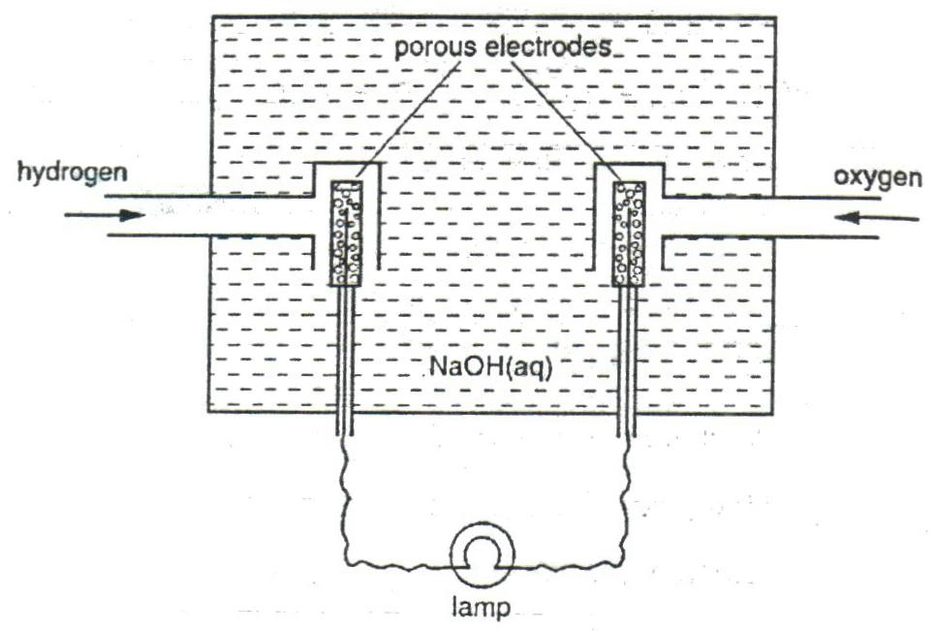  Electrode A  Electrode B  Which of the following statements about the above fuel cell is true?
  A | Electrode A is the positive electrode.
  B | Electrons flow from electrode A to electrode B.
  C | The cell e.m.f. under standard conditions is +0.40 V.
  D | The electrode potential of B becomes more positive as the concentration of NaOH increases.

12 | One mole of magnesium, aluminium and sulfur are each completely burnt in an excess of oxygen gas.  Given that all volumes are measured at the same temperature and pressure, which graph shows the volume of oxygen used in each case?
A | x  x  x  Volume of oxygen used  0  Mg Al S | B | x  x  x  Volume of oxygen used  0  Mg Al S
C | x  x  x  Volume of oxygen used  0  Mg Al S | D | x  x  x  Volume of oxygen used  0  Mg Al S

13 | Slaked lime, Ca(OH)₂, may be made from limestone, CaCO₃.  On heating in a lime kiln at 1000 ºC, limestone decomposes as follows.  reaction 1: CaCO₃(s) → CaO(s) + CO₂(g) ΔH₁  Water is then reacted with calcium oxide, CaO, as follows.  reaction 2: CaO(s) + H₂O(l) → Ca(OH)₂(s) ΔH₂  What are the enthalpy changes of these reactions?
   | ΔH₁ | ΔH₂
  A | − | −
  B | − | +
  C | + | −
  D | + | +

14 | A sample of aqueous silver nitrate is treated with successive additions of:  - an excess of KCl(aq);  - an excess of NH₃(aq);  - an excess of KBr(aq).  Which of the following diagrams represents the mass of precipitate (ppt) present after each addition?
A | Mass of ppt  (i) (ii) (iii) | B | Mass of ppt  (i) (ii) (iii)
C | Mass of ppt  (i) (ii) (iii) | D | Mass of ppt  (i) (ii) (iii)

15 | A student observed the reactions when sodium chloride was added separately to concentrated sulfuric acid and concentrated phosphoric acid. The experiment was repeated using sodium iodide. The observations were recorded in the table.  Which deduction can be made from these observations?
   | sodium chloride | sodium iodide
  conc. H₂SO₄ | white fumes evolved | purple vapour evolved
  conc. H₃PO₄ | white fumes evolved | white fumes evolved
A | Concentrated phosphoric acid is a stronger oxidizing agent than concentrated sulfuric acid.
B | Concentrated phosphoric acid is a weaker acid than concentrated sulfuric acid.
C | The reducing power of HI is greater than that of HCl.
D | The bond energy of HI is greater than that of HCl.

16 | In black and white photographic film, light converts silver chloride into metallic silver. After the film has been developed, the unexposed silver chloride is removed by reaction with sodium thiosulfate to produce a ‘fixed’ negative.  AgCl + 2S₂O₃²⁻ → Cl⁻ + [Ag(S₂O₃)₂]³⁻  Which of the following statements about the above reaction is not correct?
A | S₂O₃²⁻ acts as a ligand.
B | A complex ion is formed.
C | [Ag(S₂O₃)₂]³⁻ is linear about Ag.
D | Ag undergoes a change in oxidation state.

17 | Mohr’s salt is a pale green crystalline solid which is soluble in water. It is a ‘double sulfate’ which contains two cations, one of which is Fe²⁺.  The identity of the second cation was determined by heating solid Mohr’s salt with solid sodium hydroxide and a colourless gas was evolved. The gas formed dense white fumes upon contact with a glass rod dipped in concentrated HCl. A grey-green solid residue was also formed which was insoluble in water.  What are the identities of the gas and the solid residue?
   | gas | residue
  A | H₂ | FeSO₄
  B | CO₂ | Fe(OH)₃
  C | NH₃ | Fe(OH)₂
  D | SO₂ | Fe₂(SO₄)₃

18 | Aqueous copper(II) sulfate forms a deep blue solution when aqueous ammonia is added. The colour intensity of the mixture can be analysed by measuring its absorbance using a colorimeter.  Which of the following graphs correctly represents the absorbance against volume of solutions used when 0.05 mol dm⁻³ CuSO₄ is mixed with 0.10 mol dm⁻³ NH₃ in the given proportions?
A | Absorbance  Volume / cm³  0 3.33 5 6.67 10 0.05 mol dm⁻³ CuSO₄  10 6.67 5 3.33 0 0.10 mol dm⁻³ NH₃
B | Absorbance  Volume / cm³  0 3.33 5 6.67 10 0.05 mol dm⁻³ CuSO₄  10 6.67 5 3.33 0 0.10 mol dm⁻³ NH₃
C | Absorbance  Volume / cm³  0 3.33 5 6.67 10 0.10 mol dm⁻³ CuSO₄  10 6.67 5 3.33 0 0.05 mol dm⁻³ NH₃
D | Absorbance  Volume / cm³  0 3.33 5 6.67 10 0.10 mol dm⁻³ CuSO₄  10 6.67 5 3.33 0 0.05 mol dm⁻³ NH₃

19 | A pheromone is a secreted or excreted chemical factor that triggers a social response in members of the same species. Compound A below is an example of pheromones.  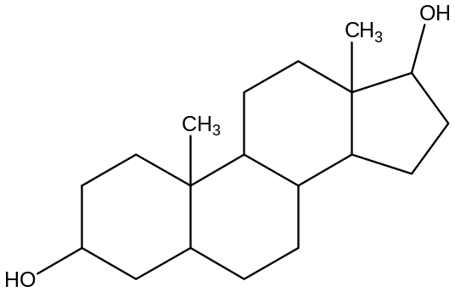  Compound A  How many possible isomers, including stereoisomers, can be obtained when A is heated with excess concentrated sulfuric acid?
  A | 2⁶ | B | 2⁷ | C | 2⁸ | D | 2⁹

20 | Benzene undergoes Friedel-Crafts acylation with ethanoyl chloride to form phenyl ethanoate, which can be represented as follow:  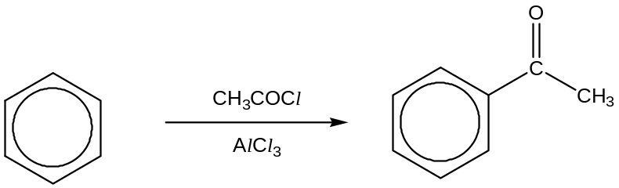  The mechanism of the above reaction is similar to that of the bromination of benzene.  Which of the following statements is not correct about the mechanism?
A | The organic intermediate has a ring with one sp³ hybridised carbon.
B | The mechanism involves CH₃CO⁺ as an electrophile.
C | The overall order of reaction is 1.
D | AlCl₃ is a homogeneous catalyst.

21 |  | An alkane E with the molecular formula C₄H₁₀ reacts with chlorine gas in the presence of light to form two monochlorinated alkanes F and G in the molar ratio of 9:1.  What are the structures of E and F?
 | E | F
A | CH₃CH₂CH₂CH₃ | CH₃CH₂CH₂CH₂Cl
B | CH₃CH₂CH₂CH₃ | CH₃CH₂CHClCH₃
C | CH₃CH(CH₃)CH₃ | CH₃CCl(CH₃)CH₃
D | CH₃CH(CH₃)CH₃ | CH₃CH(CH₃)CH₂Cl

22 | Saccharin was an artificial sweetener used in some soft drinks. It was manufactured from methylbenzene by a series of reactions.  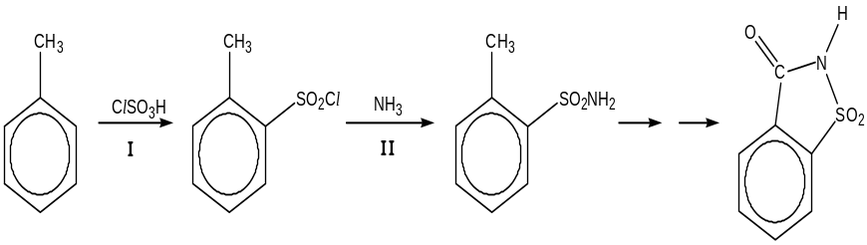  Which of the following shows the correct reaction type for steps I and II?
   | I | II
  A | electrophilic substitution | electrophilic addition
  B | electrophilic substitution | nucleophilic substitution
  C | nucleophilic substitution | electrophilic substitution
  D | nucleophilic substitution | nucleophilic addition

23 | Which sequence shows the compounds in order of decreasing pK_{a} values?
  A | CH₃CO₂H > CF₃CO₂H > C₂H₅OH > C₆H₅OH
  B | CF₃CO₂H > CH₃CO₂H > C₆H₅OH > C₂H₅OH
  C | C₂H₅OH > C₆H₅OH > CH₃CO₂H > CF₃CO₂H
  D | C₆H₅OH > C₂H₅OH > CH₃CO₂H > CF₃CO₂H

24 |  | The following compound is tested with two reagents separately.  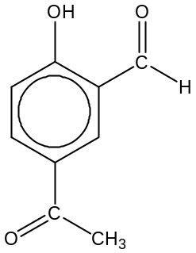  What are the expected observations?
   | Warm with Fehling’s reagent | Warm with Tollens’ reagent
  A | Brick-red precipitate | Silver mirror
  B | No precipitate | Silver mirror
  C | Brick-red precipitate | No silver mirror
  D | No precipitate | No silver mirror
 | 25 |  | 1 mole of an organic compound X reacts with 1 mole of NaOH. 1 mole of X also reacts with PCl₅ to produce 1 mole of hydrogen chloride.  Which compound could be X?
A | 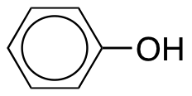
B | 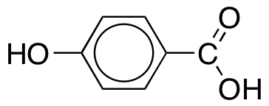
C | 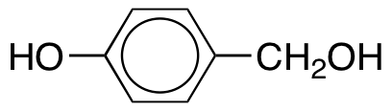
D | 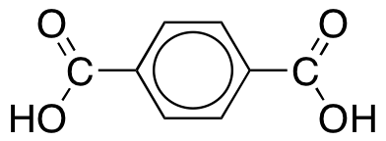

26 | Paracetamol is a common analgesic used in the treatment of fever and headaches.  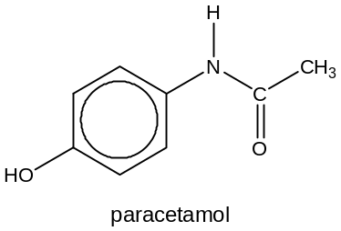  Which deduction about paracetamol can be made from this structure?
A | It is a planar molecule.
B | It contains an amine group.
C | It reacts with sodium metal.
D | It gives an orange precipitate with 2,4-dinitrophenylhydrazine.

27 | The same product is obtained when separate samples of P and Q are respectively heated in a sealed tube with ammonia and reacted with lithium aluminium hydride in dry ether.  Which are the structures of P and Q?
 | P | Q
A | C₆H₅Br | C₆H₅CN
B | CH₃CH(Br)CH₃ | CH₃CH(CN)CH₃
C | CH₃CH₂CH₂Br | CH₃CH₂CN
D | CH₃CH(Br)CH₃ | CH₃CH₂CN

28 | The reaction scheme below shows the synthesis of compound S.  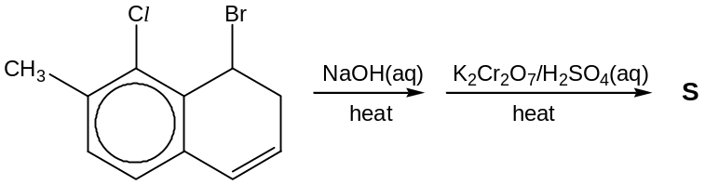  Which of the following can be S?
A | 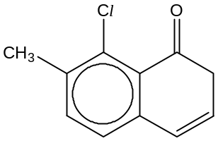 | B | 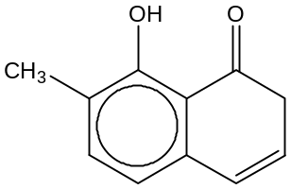
C | 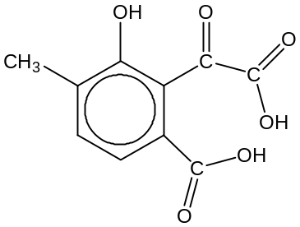 | D | 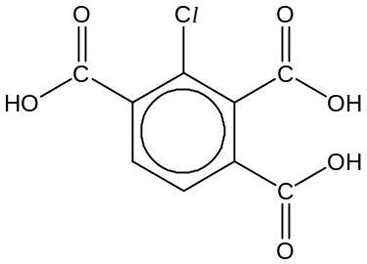

29 | Compound Y has the following properties:  (i) it does not decolourise aqueous bromine;  (ii) it produces an effervescence when reacted with Na₂CO₃(aq) and  (iii) it decolourises hot acidified KMnO₄(aq).  Which of the following can be Y?
A | 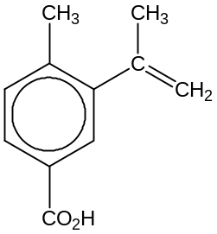 | B | 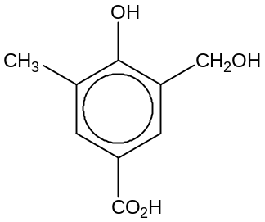
C | 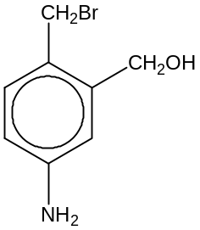 | D | 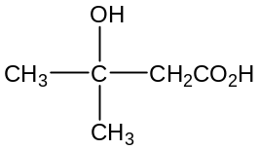

30 | The Diels-Alder reaction is an organic reaction between a conjugated diene and a substituted alkene to form a substituted cyclohexene system. One such reaction between buta-1,3-diene and but-3-en-2-one is shown below.  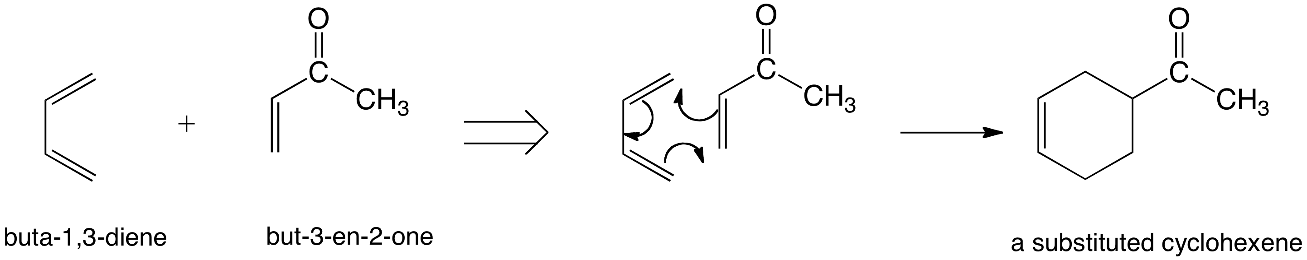  What would be the product formed when the following diene and substituted alkene reacts in a 1:1 ratio?  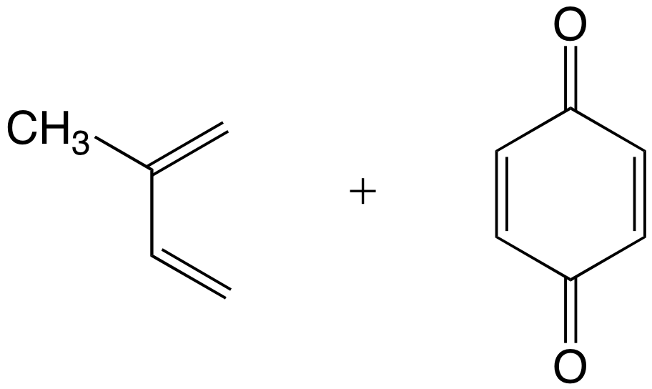
A | 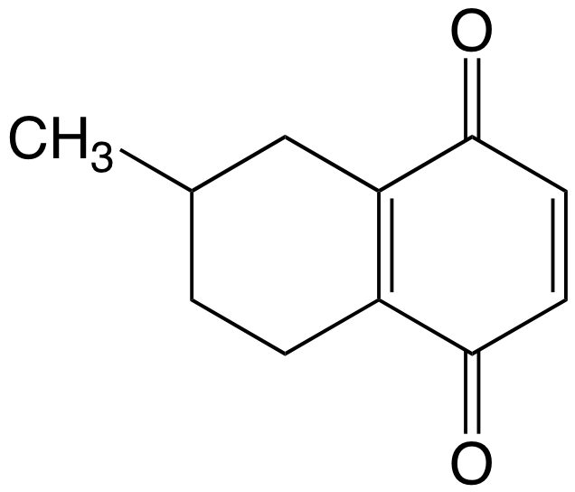 | B | 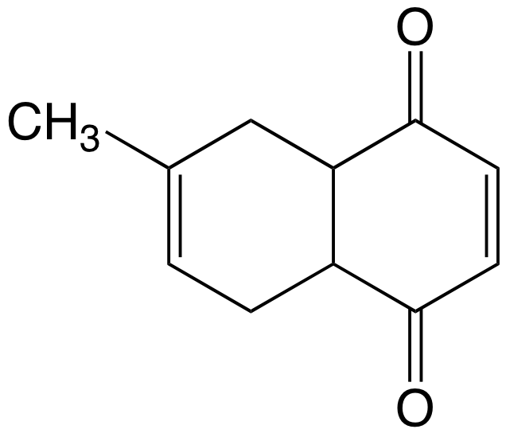
C | 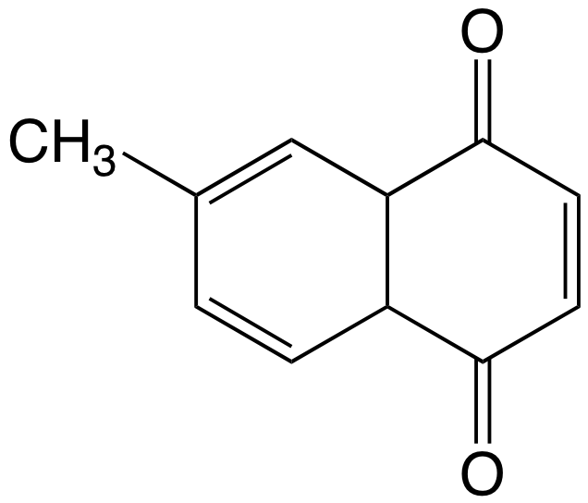 | D | 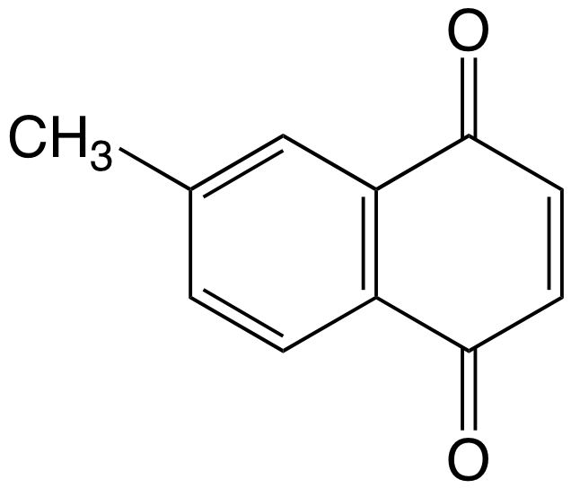

Section B

For each of the questions in this section, one or more of the three numbered statements
1 to 3 may be correct.

Decide whether each of the statements is or is not correct. (You may find it helpful to put a tick against the statements that you consider to be correct).

The responses A to D should be selected on the basis of

A | B | C | D
1, 2 and 3 are correct | 1 and 2 only are correct | 2 and 3 only are correct | 1 only is correct

31 | Magnesium reacts readily with dilute hydrochloric acid to form magnesium chloride and hydrogen.  Mg(s) + 2HCl(aq) → MgCl₂(aq) + H₂(g)  The standard enthalpy change for this reaction can be measured in the laboratory.  What further information is needed in order to calculate the standard enthalpy change of formation of magnesium chloride?
1 | ΔH_{f} for HCl(aq)
2 | ΔH_{f} for H₂(g)
3 | first and second ionisation energies of Mg

32 | A theoretical reaction involves A + B → product.  The rate equation is rate = k[A]^{p}[B]^{q} and the units of the rate constant, k, are (mol dm⁻³)^{r} min⁻¹.  Which sets of the values of p, q and r fit the above information?
   | p | q | r
  1 | 0 | 1 | 0
  2 | 1 | 2 | −2
  3 | 2 | 0 | −1

The responses A to D should be selected on the basis of

A | B | C | D
1, 2 and 3 are correct | 1 and 2 only are correct | 2 and 3 only are correct | 1 only is correct

33 | The titration curve of the protonated form of an amino acid is as shown.  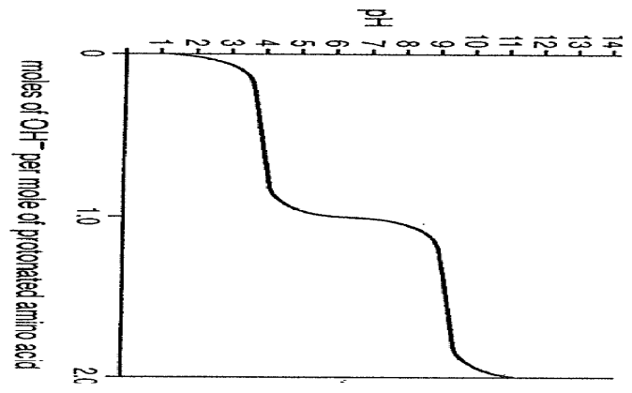  The two stages of titration are associated with two different dissociation constants, K₁ and K₂.  Which statements are always correct for any amino acid?
  1 | The form H₃N⁺CHRCO₂⁻ is the most common species present at pH 7.
  2 | Equal concentrations of H₃N⁺CHRCO₂H and H₃N⁺CHRCO₂⁻ are present at pH = pK₁.
  3 | There is no net charge on the amino acid at the point when the slope of the curve is at a maximum at its centre.

34 | A mixture of two oxides of Period 3 elements is added to water. The solution formed is almost neutral.  What could the constituents of the mixture be?
1 | Na₂O and P₄O₁₀
2 | MgO and SiO₂
3 | P₄O₁₀ and SO₃

35 | Radium is below barium in the Periodic Table. Which of the following statements is expected for radium, ₈₈Ra, or its compounds?
1 | Its oxide is basic.
2 | The lattice energy of radium oxide is less exothermic than that of barium oxide.
3 | It reacts vigorously with water to release hydrogen gas.

36 | Which of the following statements are true regarding compound Z?  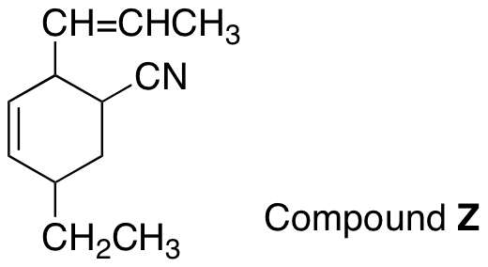
1 | There is only one sp hybridised carbon atom in a molecule of Z.
2 | A molecule of Z contains four π bonds.
3 | After Z reacts with LiAlH₄, all the carbon atoms in the product formed are sp³ hybridised.

37 | Adrenaline and hydrocortisone are hormones produced by the adrenal glands.  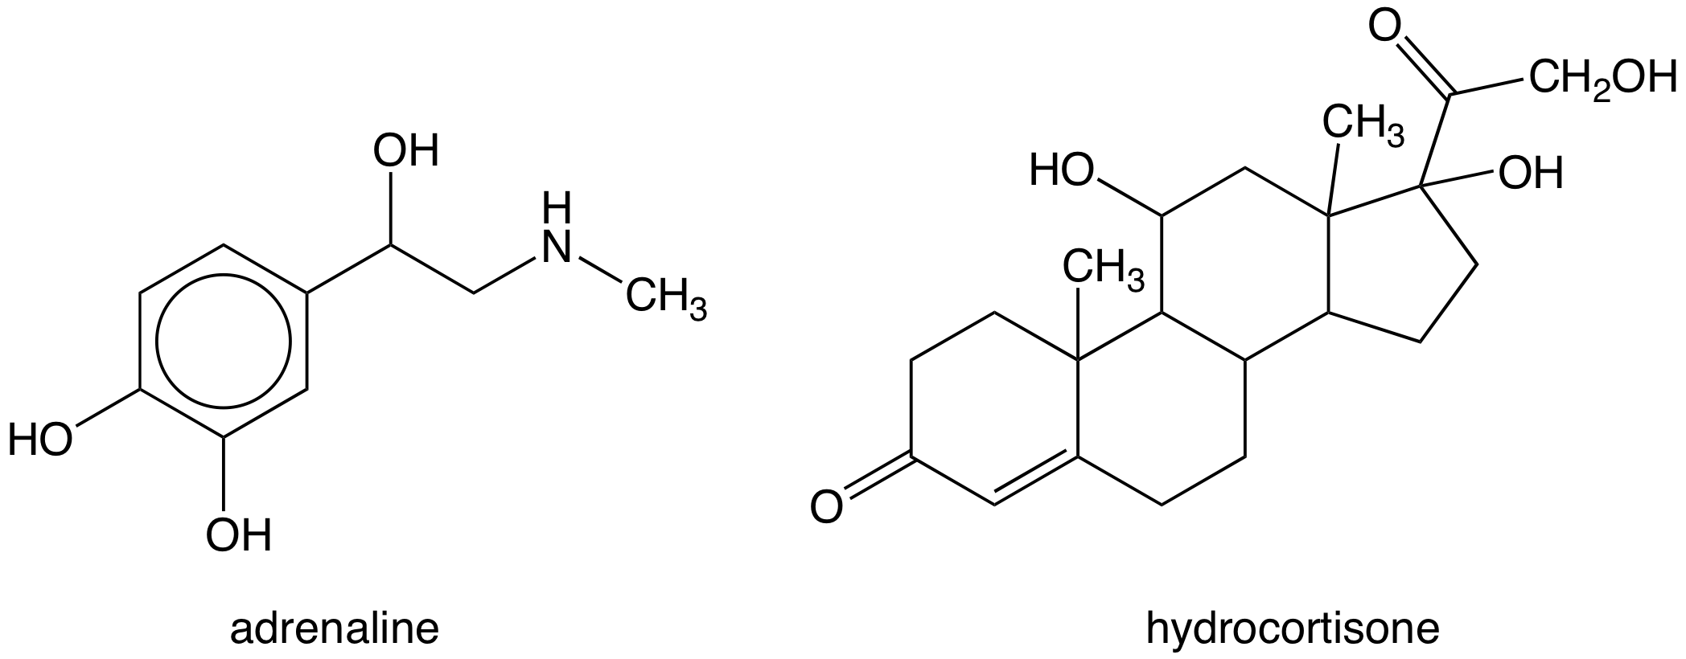  Which of the following reagents are able to distinguish the two hormones?
1 | Aqueous neutral FeCl₃
2 | Hot aqueous potassium dichromate(VI), K₂Cr₂O₇(aq)
3 | Aqueous bromine, Br₂(aq)

38 | The diester R, which is used in perfumes, has the molecular formula C₇H₁₂O₄. It is found that one of the products of acid hydrolysis of R produces effervescence when heated with acidified KMnO₄(aq).  Which of the following structures can be compound R?
1 | CH₃CO₂CH₂CH₂OCOCH₂CH₃
2 | CH₃CH₂OCOCH₂CO₂CH₂CH₃
3 | CH₃CO₂CH₂CH₂CO₂CH₂CH₃

The responses A to D should be selected on the basis of

A | B | C | D
1, 2 and 3 are correct | 1 and 2 only are correct | 2 and 3 only are correct | 1 only is correct

39 | 1-bromopropane can be converted to propanone in exactly three steps.  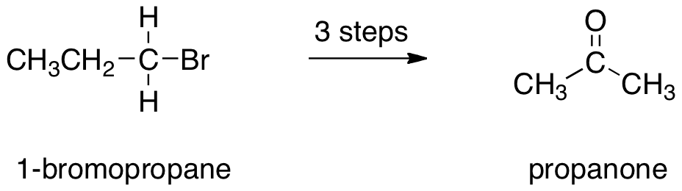  Which of the following reagents can be used in the conversion?
1 | Aqueous NaOH
2 | Ethanolic NaOH
3 | Acidified KMnO₄

40 | A tripeptide, cys-ala-his, was analysed using electrophoresis. The tripeptide was hydrolysed and the resulting solution was added to a buffer solution of pH 6.00 which was then placed at the centre of the plate. A potential difference was then applied across the plate.  With reference to the above table, which of the following statements are correct?
  Amino acid | 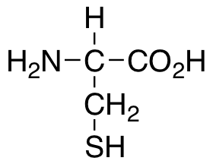  cysteine (cys) | 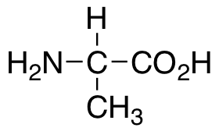  alanine (ala) | 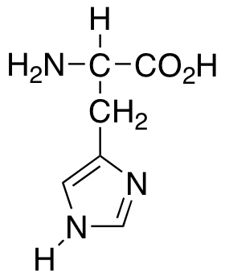  histidine (his)
  Isoelectric point | 5.05 | 6.00 | 7.60
1 | Alanine would remain at the centre of the plate.
2 | Cysteine would migrate towards the anode.
3 | Histidine would migrate towards the cathode.

~ End of Paper 1~

